**IDEATION PHASE**

**BRAINSTROM AND PRIORITIZE**

|  |  |
| --- | --- |
| **Date** | **03 NOVEMBER 2023** |
| **Team ID** | **NM2023TMID04737** |
| **Project name** | **A CRM APPLICATION FOR MANAGEMING LOAN APP AND FRADULENT PREVENTION** |
|  |  |

A CRM APPLICATION FOR MANAGING LOAN APP AND FRADULENT PREVENTION

Brainstorm

**TIP**

Add customizable tags to sticky notes to make it easier to find, browse, organize, and categorize important ideas as themes within your mural.

**TIP**

Participants can use their cursors to point at where sticky notes should go on the grid. The facilitator can confirm the spot by using the laser pointer holding the **H key** on the keyboard.

**Template**

& idea prioritization

Use this template in your own brainstorming sessions so your team

**Before you collaborate**

A little bit of preparation goes a long way with this session. Here’s what you need to do to get going.

**10 minutes**

**A Team gathering**

Define who should participate in the session and send an invite. Share relevant information or pre-work ahead.

**B Set the goal**

**1**

### Define your problem statement

What problem are you trying to solve? Frame your problem as a How Might We statement. This will be the focus of your brainstorm.

**5 minutes**

**2**

### Brainstorm

**TIP**

You can select a sticky note and hit the pencil [switch to sketch] icon to start drawing!

Write down any ideas that come to mind that address your problem statement.

**10 minutes**

### SHYAMBABU S NARESHKUMAR G

**3**

### Group ideas

Take turns sharing your ideas while clustering similar or related notes as you go. Once all sticky notes have been grouped, give each cluster a sentence-like label. If a cluster is bigger than six sticky notes, try and see if you and break it up into smaller sub-groups.

**20 minutes**

**4**

### Prioritize

Your team should all be on the same page about what's important moving forward. Place your ideas on this grid to determine which ideas are important and which are feasible.

**20 minutes**

**+**

reduce burden

**After you collaborate**

You can export the mural as an image or pdf to share with members of your company who might find it helpful.

#### Quick add-ons

**A Share the mural**

**Share a view link** to the mural with stakeholders to keep them in the loop about the outcomes of the session.

**Export the mural**

can unleash their imagination and start shaping concepts even if you're not sitting in the same room.

Think about the problem you'll be focusing on solving in

the brainstorming session.

**C Learn how to use the facilitation tools**

Use the Facilitation Superpowers to run a happy and

update the

details for AI

Assitance

implement

the AI for get easy work

reduce burden

easy to place

work without humans

**PROBLEM**

Recruiting Assistance For The HR Managers

reduce burden

AI

assitance

**B**

Export a copy of the mural as a PNG or PDF to attach to emails, include in slides, or save in your drive.

**10 minutes** to prepare

**1 hour** to collaborate

**2-8 people** recommended

productive session.

[**Open article**](https://support.mural.co/en/articles/2113740-facilitation-superpowers)

#### Key rules of brainstorming

To run an smooth and productive session

Reduce HR burden

## work without humans

work easy

AI

assitance

implement the AI for

#### Keep moving forward

**Strategy blueprint**

Define the components of a new idea or strategy.

[**Open the template**](https://app.mural.co/template/e95f612a-f72a-4772-bc48-545aaa04e0c9/984865a6-0a96-4472-a48d-47639307b3ca)

**Customer experience journey map**

Understand customer needs, motivations, and

Stay in topic.

Defer judgment.

Encourage wild ideas.

Listen to others.

#### Importance

If each of these tasks could get

get easy work

obstacles for an experience.

[**Open the template**](https://app.mural.co/template/b7114010-3a67-4d63-a51d-6f2cedc9633f/c1b465ab-57af-4624-8faf-ebb312edc0eb)

Go for volume. If possible, be visual.

work without humans

**SURYA S**

AI

assitance

AI

assitance

### YUVRAJ S

reduce burden

done without any difficulty or cost, which would have the most positive impact?

easy to place

**Strengths, weaknesses, opportunities & threats**

Identify strengths, weaknesses, opportunities, and threats (SWOT) to develop a plan.

|  |  |
| --- | --- |
|  |  |
|  |  |

[**Open the template**](https://app.mural.co/template/6a062671-89ee-4b76-9409-2603d8b098be/ca270343-1d54-4952-9d8c-fbc303ffd0f2)

[**Share template feedback**](https://muralco.typeform.com/to/CiqaHVat?typeform-source=app.mural.co)

## reduce burden

work easy

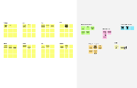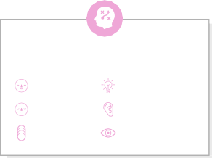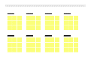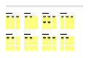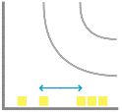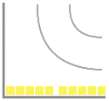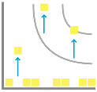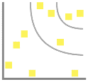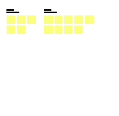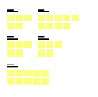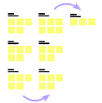

# -

#### - Feasibility +

Regardless of their importance, which tasks are more feasible than others? (Cost, time, effort, complexity, etc.)

**Need some inspiration?**

See a finished version of this template to kickstart your work.

[**Open example**](https://app.mural.co/template/e5a93b7b-49f2-48c9-afd7-a635d860eba6/93f1b98d-b2d2-4695-8e85-7e9c0d2fd9b9)